From: Barbara prince [bprince@haddontwp.com]
Sent: Tuesday, October 21, 2008 9:45 AM
To: 'bbrookes@haddontwp.com'; 'Betty Band'; 'dbrodo@haddontwppolice.com'; 'Denise P. Adams'; 'dalfonsi@haddontwp.com'; 'jcfacf@comcast.net'; 'Kate Burns'; 'lmoran@haddontwp.com'; 'Mary Twisler'; 'Margaret King'; 'Pat Thieringer'; 'pdougherty@haddontwp.com'; 'Shirley Johnson'; 'TeagueLaw@comcast.net'; 'KEarney@HaddonTwpPolice.com'; 'cmelnyk@haddon.k12.nj.us'; 'Mark Cavallo'; 'mtalucci@haddontwp.com'; 'brichards@haddontwp.com'
Subject: Recycling Update
Attachments: paper and electronic recycling 008.jpg; paper and electronic recycling 011.jpg

Thanks to all your efforts, …

RECYCLING THRIVES IN HADDON TOWNSHIP!
KEEP UP THE GOOD WORK!

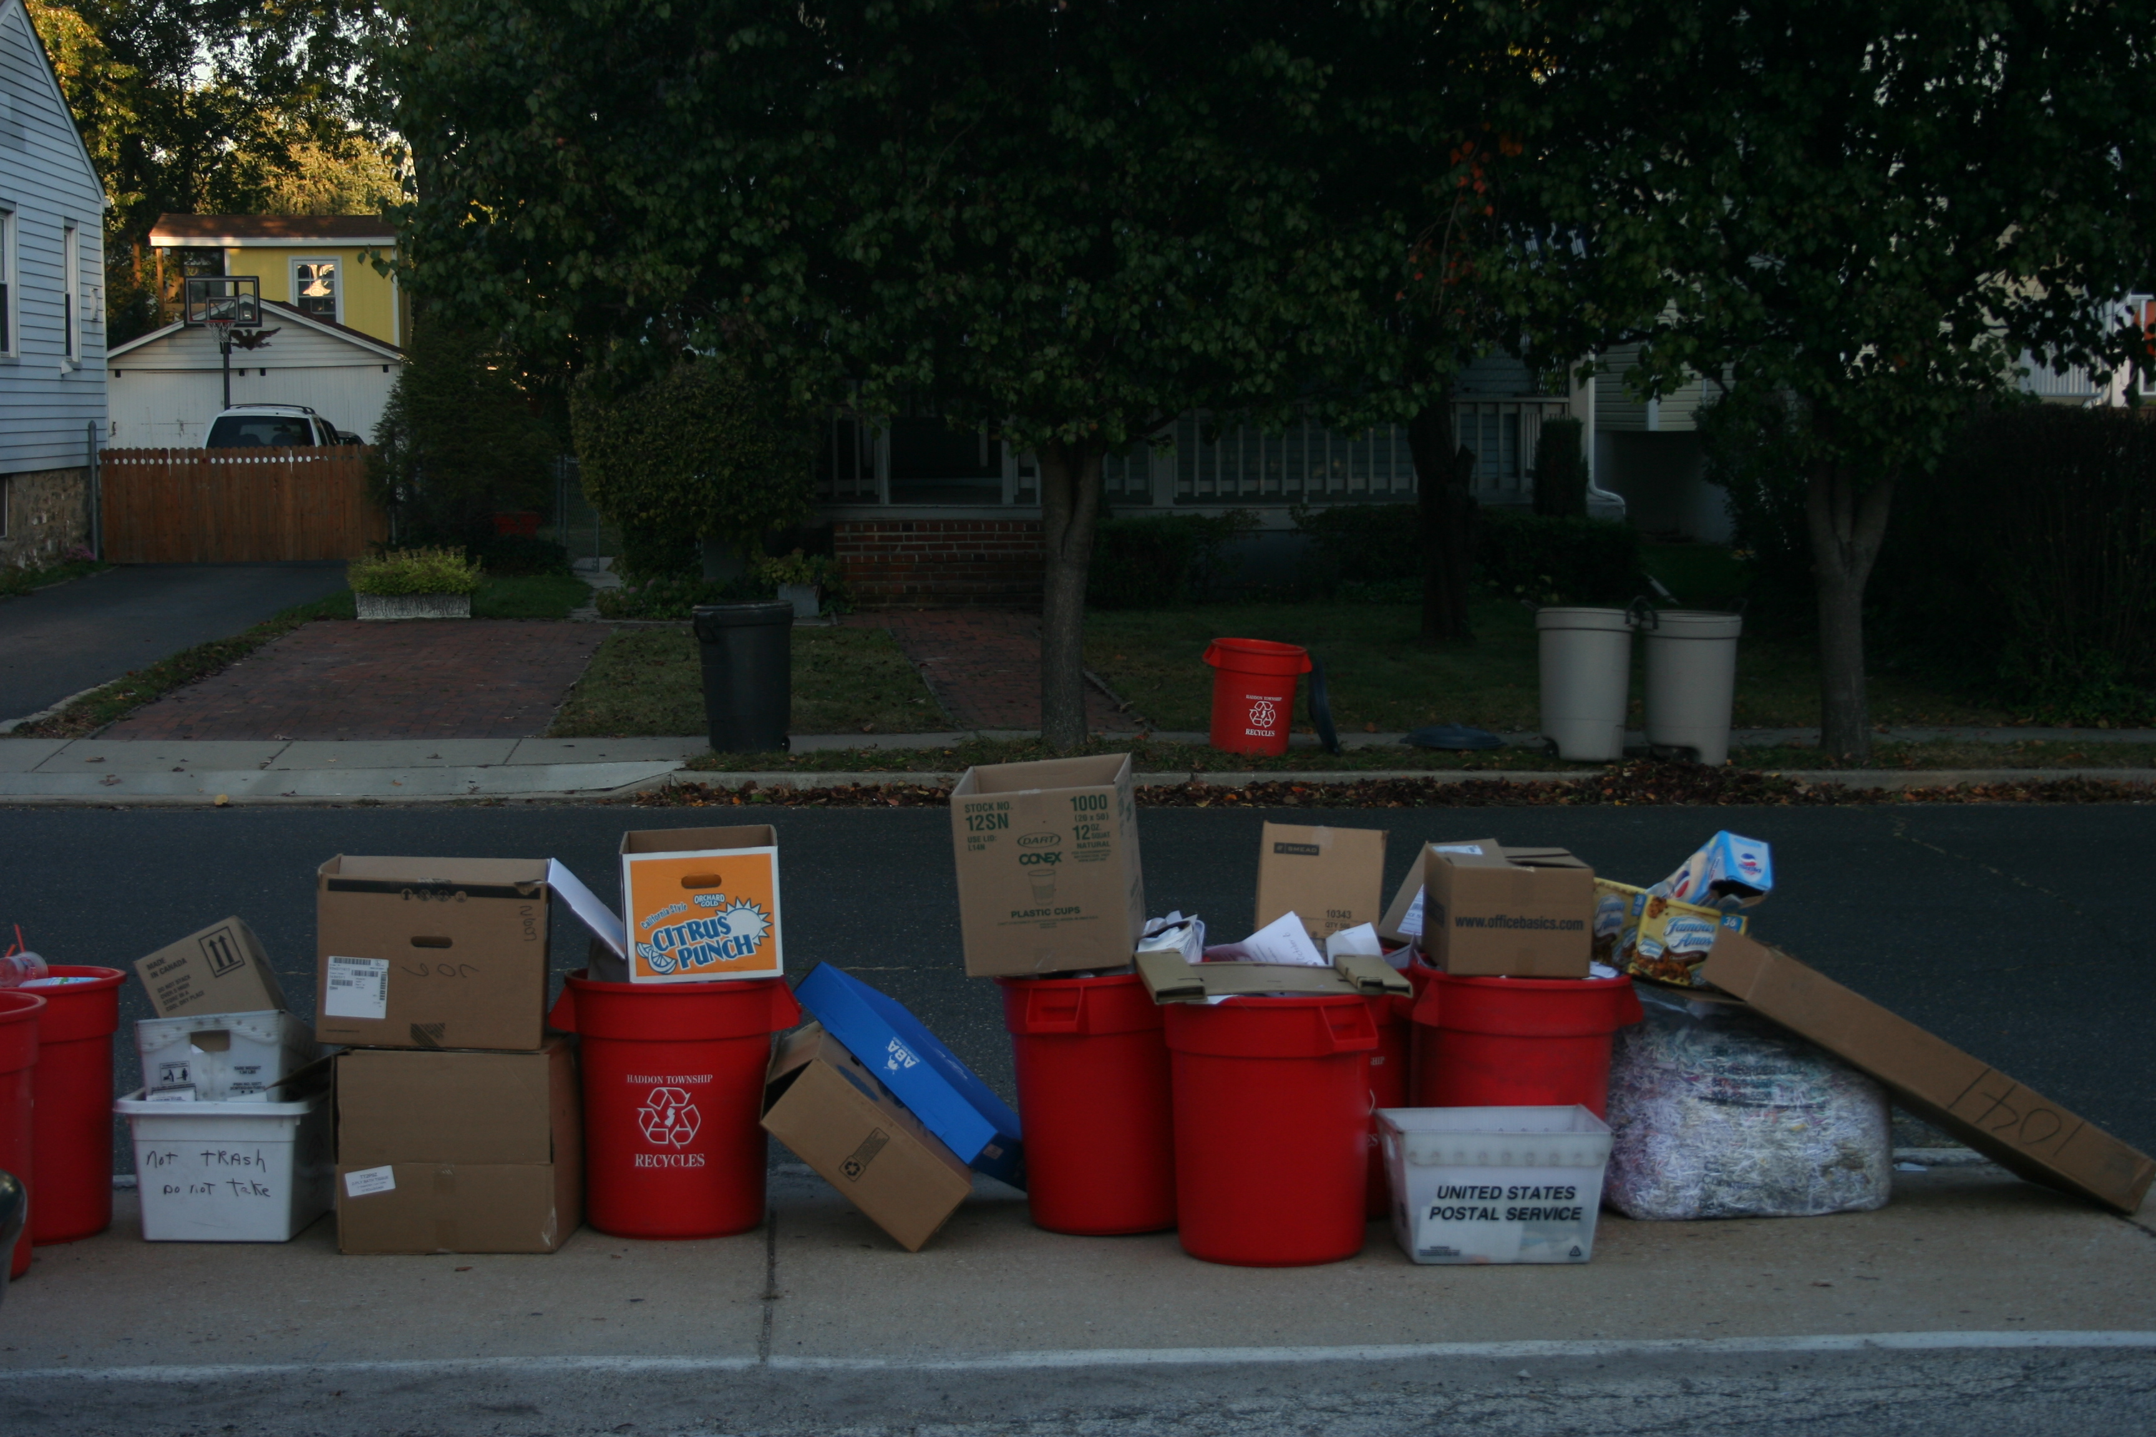

BEST REGARDS,
Barbara Prince
CHECK OUT THE PICTURES…

