
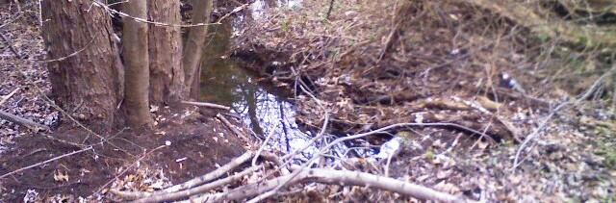
sustainability plan
an element of the master plan


township council
David Fleisher,
N. John Amato,
James Bannar
Susan Shin-Angulo
Joyce Kurzweil
Dennis Garbowski
Sara Lipsett
Jacquelene Silver

planning board
Alan Miller, Chair
Aimee Hansen, Vice-Chair
Michael Maitland
Raymond Benitez
Councilwoman Sara Lipsett
Hugh Dougherty, PE
Michael Vozzeli
William McCargo
John S. Osorio, Esq.
Olvin S. Rouse, Jr., Alternative #1
H. Marc Tepper, Alternative #2

Mayor Bernie Platt

David J. Benedetti, PP, AICP
Nicole Hostettler, PP, AICP
Natalie Shafiroff

JULY 2010

TABLE OF CONTENTS

plan summary. 4

introduction. 5
Defining Sustainability
Why does it matter?
Rising Temperatures
Increased Precipitation
Water Level
Benefits of a Sustainable Community

analysis. 13
Baseline Inventory
Indicators
LAND USE
TRANSPORTATION
ENERGY
WASTE

action plan. 21
LAND USE
TRANSPORTATION
ENERGY
WASTE

emissions reduction target. 24

current initiatives. 26
Cherry Hill
Camden County
Delaware Valley
New Jersey

implementation. 31

appendix. 32 New Jersey Green Municipalities
More Information

plan summary.
Cherry Hill Township exemplifies the type of residential and commercial growth that occurred between the 1950s and 1980s, wherein the burgeoning federal highway system allowed for the suburban landscapes ubiquitous today. What once were two-lane rural routes through farmland are now four-lane divided highways; the agricultural fields that dominated Cherry Hill in the first half of the century are now paved over and replaced with housing subdivisions, shopping centers, medical facilities, schools, and office complexes. Development over this pivotal growth period in the township’s history has necessitated dependence on automotive travel, whether commuting across town – or across the street in many cases.
Such vehicular-reliant land-use patterns are difficult to reverse, and the resulting automotive emissions released by the more than 200,000 vehicles motoring throughout the Township each day have saddled it with one of region’s largest carbon footprints. In addition, Cherry Hill’s thousands of businesses and nearly 25,000 homes – coupled with many other buildings – significantly contribute to that footprint through heavy energy consumption, waste output, and impervious ground cover.
While inhabited by individuals and businesses in support of adopting greener and environmentally friendly lifestyles or operations, Cherry Hill would benefit from a wide-ranging, long-term plan fostering a shift toward sustainability at all levels – from residential to commercial to institutional.
For example, creating overlay zones to direct the Township’s physical layout and offer various communities the option for non-vehicular mobility would result in a considerable reduction in engine emissions and subsequent improvement in air quality; setting municipal goals for reduced energy consumption, while creating incentives for other structural entities to do the same, would also diminish Cherry Hill’s sizeable carbon footprint and the negative impact it has on local resources and the environment as a whole.
With both the needs of the present and those of future generations in mind, this Sustainability Plan outlines the benefits of laying the foundation for a sustainable community, and fostering recommended land-use, transportation, energy, and waste-management initiatives that will achieve this vision.
What follows is an analysis of Cherry Hill’s current baseline inventories of the four major components of sustainability (land-use, transportation, energy, and waste), as well as an overview of “green” programs that exist locally and throughout the region, target emission reduction goals specifically pertaining to the township, and a proposed action plan complete with steps for implementation. Taken as a whole, this Sustainability element of the Master Plan is a blueprint for a sustainable future, and essential to maintaining the vitality of the Cherry Hill community for centuries to come.

introduction.

The Township of Cherry Hill is one of the largest suburban municipalities of Philadelphia located in Southern New Jersey. The Township extends over 24 square miles, developed over several decades. The land use of the western portion of the Township is indicative of an inner-ring suburb, which is undergoing recent revitalization. Once known as Delaware Township, it was vastly composed of farms and orchards with secondary growth outside the historic downtowns that surround the PATCO high-speed line stations. Rapid growth occurred eastward starting in the 1950’s through the 1990’s, resulting in a consumptive land use pattern largely dependent on the automobile. These land use patterns, indicative of suburban communities throughout the US, are a major contributor to climate change.
The impact of climate change is becoming more apparent and affecting a growing number of people. The demonstration of environmental concern by the community and the importance of a sustainable future have led to the creation of this Sustainability Plan. Township Council and the administration are taking a proactive approach to the Township’s role in the overall environment by creating and implementing sustainable initiatives for the operation of Township government, as well as the residents and business owners within Cherry Hill. The intent of the Cherry Hill Sustainability Plan is to strive toward a sustainable community and shrink our carbon footprint through the development of a green action plan.
In 2008, the Municipal Land Use Law (M.L.U.L) was amended to create an additional and optional element of a comprehensive plan (Bill A1559), allowing the adoption of a sustainability plan (C.40:55D-1 et seq.):
A green buildings and environmental sustainability plan element, which shall provide for, encourage, and promote the efficient use of natural resources and the installation and usage of renewable energy systems; consider the impact of buildings on the local, regional and global environment; allow ecosystems to function naturally; conserve and reuse water; treat storm water on-site; and optimize climatic conditions through site orientation and design.
Another bill recently passed (A-3062, S-1303) recognizes wind, solar, or photovoltaic facilities as an “Inherently Beneficial Use” per the M.L.U.L. By placing it in the “Inherently Beneficial Use” category, a facility of that type would be considered a value to the community and would be included with other uses such as hospitals, schools, or child care centers.
The Cherry Hill Sustainability Plan identifies four initial areas in which the Township may implement sustainable improvements:
LAND USE TRANSPORTATION ENERGY WASTE

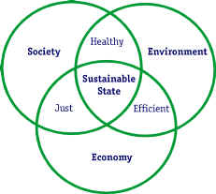
This plan upholds environmental sustainability as a priority throughout the Township, as well as establishes leadership qualities for our community to implement and follow. These initiatives will be pursued by a strong partnership with Sustainable Cherry Hill (SHC), Cherry Hill Environmental Advisory Committee (CHEAC), and Township staff and officials. This partnership will be critical for developing initiatives, creating community awareness of environmental issues and educating the public. This Sustainability Plan will provide analysis of existing conditions, identify deficiencies to be improved, determine actions and initiatives, identify resources for implementation, and address monitoring and evaluation techniques.

DEFINING SUSTAINABILITY
The term sustainability has become a common catch phrase since its initial use by the United Nation's World Commission on Environment & Development (the Brundtland Commission) in 1987. The Commission defined sustainable development as “development that meets the needs of the present without compromising the ability of future generations to meet their own needs.” This idea is the essence of sustainability, leaving a planet to our children and grandchildren that will still be able to provide them with sustenance, shelter, and economic opportunity.

Municipalities are in a unique position to influence and educate local residents about sustainable development by both incorporating sustainable practices into municipal activities and using the relationship to communicate ways to practice sustainability at home. This Sustainability Plan will provide a roadmap for the Township to practice sustainability in its own actions, guide developers towards energy efficient “green” building and site design, and help residents incorporate green practices into their everyday lives.

WHY DOES IT MATTER?
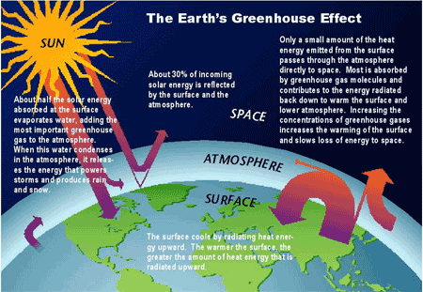
(image source: http://science.howstuffworks.com/global-warming.htm/printable, Courtesy of U.S. Global Change Research Program

Some effects of climate change are already being seen across the globe. These include rising sea levels, shrinking glaciers, increased lengths of growing seasons, lakes and rivers freezing later and breaking up earlier, and changes in the range and distributions of plant and animal life. There is no way to predict the exact impacts on different regions of the country, but there is a general expectation among scientists that there will be three major impacts that will have varying effects. These changes include rising temperatures, increased precipitation, and a rising water level. Each of these actions effect Cherry Hill Township, directly or indirectly, in the following ways:
1. Rising Temperatures
- More frequent extreme-heat days, creating more opportunities for forest fires in the Pinelands
- Dirtier air, resulting in increased asthma, longer and more intense allergy season, and increased energy costs due to resulting demand for air conditioning.
- A longer growing season, earlier leaf and bloom dates for plants, particularly the blueberry and cranberry crops that dominate Salem, Cumberland, and western Atlantic Counties.
- Shift in ecosystems of wildlife and fisheries, particularly in the tidal wetlands and Pine Barrens.
2. Increased Precipitation
- An increase in heavy rainfall events and less precipitation falling as snow.
- Earlier breakup of winter ice on the Cooper River and smaller tributaries and spring snowmelt resulting in earlier and faster waterflows, leading to additional erosion of the South Pennsauken Creek, Cooper River, and smaller tributaries.
- An increase in transmission of vector-borne bacteria, through mosquitoes, ticks, and other carriers.
3. Water Level
- Exorbitant costs to mitigate rising sea level in shore communities, resulting in much higher costs for the tourism industry.
- More severe storm surges, resulting in more damage to buildings and infrastructure in shore communities.
- A rise in the Cooper River water level, due to overflow from elevated levels in the Delaware River.
- Salt water encroachment further into the Cooper River, possibly decreasing the water quality of the CCMUA sewer and drinking water supply.

Rising Temperatures
Rising temperatures have many severe impacts including rise in sea level, decrease in food production, decrease in clean drinking water, and changes in ocean salinity effecting marine ecology. These changes can lead to drought, food supply disruption, temperature-related sickness and deaths, wildlife extinction, increased flooding in coastal regions, irreversible melts of the Greenland and Arctic ice sheets, and related effects. Developed regions experiencing warmer temperatures will inevitably lead to increased energy use to maintain air conditioning systems, refrigeration units and other modern day technologies that moderate indoor air temperatures.
From a global perspective, eleven of the last twelve years (1995-2006) rank among the twelve warmest years in the instrumental record of global surface temperature (since 1850). Locally, Southern New Jersey has experienced this temperature increase, with an increase in mean temperature of 2.1 degrees. The 2001-08 mean temperature is 54.6°, from a traditional mean temperature of 52.5° (1895-1970). Southern New Jersey (Division 2) is defined as the counties of Atlantic, Burlington, Camden, Cape May, Cumberland, Gloucester, Mercer, Middlesex, Monmouth, Ocean, and Salem counties, with the exception of the immediate coastal areas. This area encompasses approximately 56% of the land cover in New Jersey.
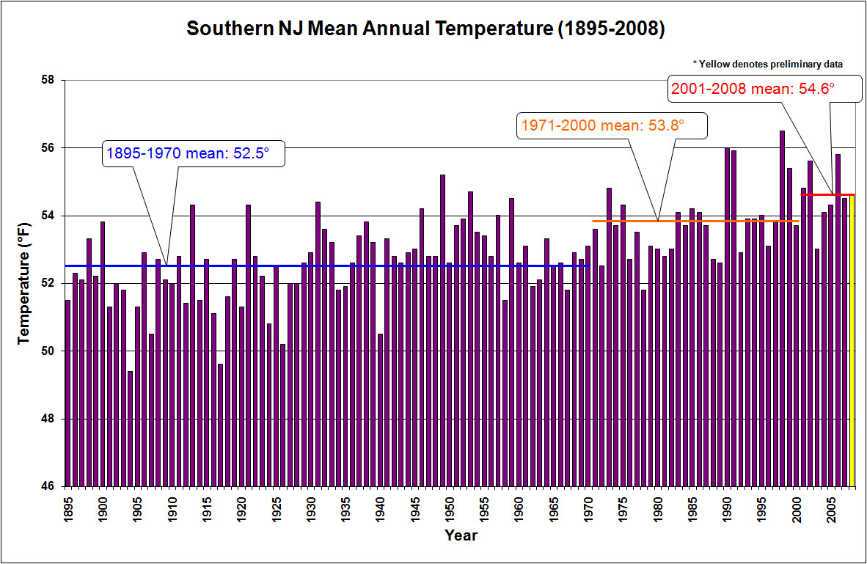
In addition to comprehensive temperature rise, more extreme heat days will occur. The nearby urbanized Camden area is projected to experience 30 or more days over 100°F, in worst case scenarios and 10 days or more under best cases. During these extreme temperature days, conditions for poor air quality are optimal. Ground level Ozone (O₃) is generally formed on very hot days, as it is created from the Sun’s rays (solar radiation) and the emissions of cars, factories, and other similar emissions. These emissions include Nitrogen Oxide (NOx) and Volatile Organic Compounds (VOC). In 2006, the Philadelphia-Camden-Vineland region was ranked the tenth most ozone-polluted metropolitan region in the U.S., according to U.S. Environmental Protection Agency (EPA) standards. As the urbanized area of the greater Camden area encompasses most of Cherry Hill Township, this would directly affect Township residents. By reducing the number of extreme heat days (in addition to emissions), we can reduce ozone, which depletes air quality.
If you suffer during the time of year when allergies act up and use your inhaler, this affects you. These symptoms are projected to worsen if current conditions persist, regardless if urban or rural. Higher temperatures and increasing levels of carbon dioxide (CO₂) are expected to accelerate seasonal pollen production in plants, thereby extending the allergy season, increasing asthma risks, and exacerbating cardiovascular and respiratory diseases.
Any entities or residents of Cherry Hill that are related to the successful cranberry or blueberry industry may be affected. The best production environment for these fruits requires long periods of winter chill, meaning an extended period of cold weather. Increased temperatures mean a shorter winter, meaning a substantial loss of crop production. Although blueberry growers may switch to varieties now grown in the South, there are currently no known low-chill cranberry varieties. In addition to these crops that dominate in Southern New Jersey, other agriculture yields that grow best in cooler conditions of our spring and fall will be affected, including spinach and lettuce. In addition to these conditions, weeds and invasive species that easily adapt will increase in strength and location, which may increase the use of pesticide and/or herbicide use.

Increased Precipitation
Scientists that study climate change have observed during the 20th century, global wide precipitation has “increased significantly” in eastern parts of North and South America, northern Europe and northern and central Asia. This increase in precipitation includes intensification in precipitation events across the northeast. The frequency in heavy rainfall is expected to increase and storm events will likely shift from early to late winter as temperatures increase.
The increase in precipitation is evident in Southern New Jersey, with an increase in mean rainfall of approximately three (3”) inches. The 2001-08 mean precipitation is 46.71”, from a traditional mean precipitation of 43.67” (1895-1970).

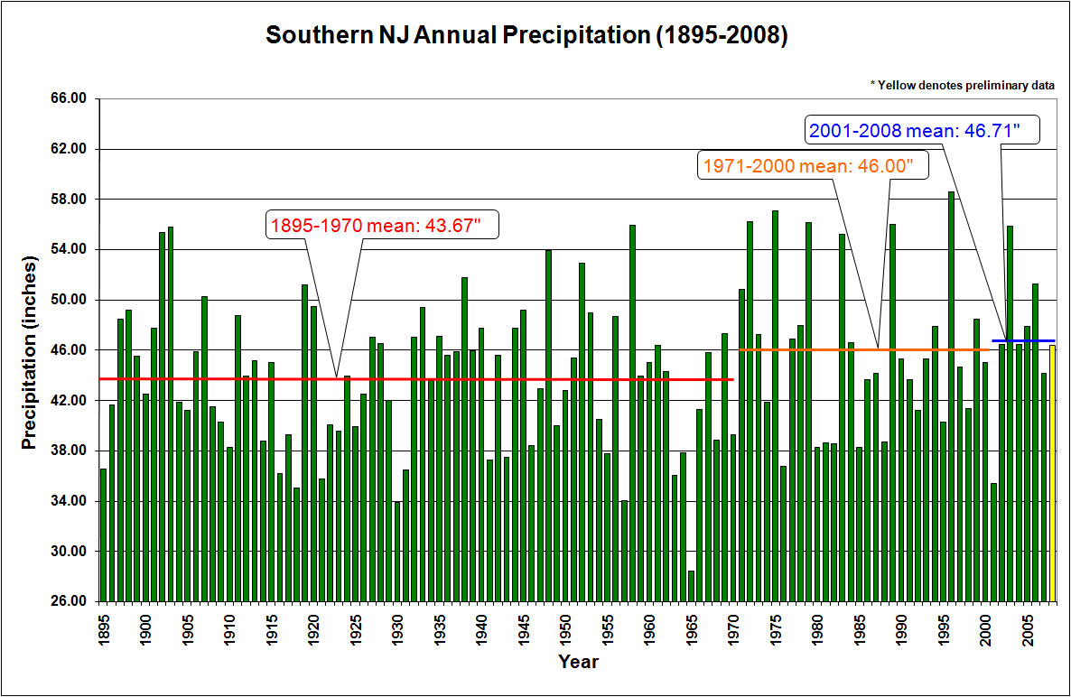
Extreme precipitation can inflict tremendous damage on homes, businesses, public infrastructure, and ecosystems, as well as disrupting our economic activity and daily lives. Several events that hit the Northeast in fall 2005 and spring 2006 resulted in loss of life and an estimated $130 million in property damage. (
Additional rainfall, earlier snow and ice melt, and more extreme precipitation events result in faster and larger volumes of water flow. This is commonly termed as ‘gallons per minute’ (gpm), a standard to measure the speed of water. The faster water moves over land the more damaging the erosion on stream banks. The condition of the South Pennsauken Creek, Cooper River, and their smaller tributaries are fragile, as illustrated in the Cherry Hill Stormwater Management Plan.
The Cooper River Regional Stormwater Management Plan characterizes much of the Cooper River stream corridor as impaired, rated sub-marginal or poor. These were characterized as such due to the eroded stream banks, incised stream channels, silted streambeds and sometimes limited stream buffer. The plan attributes a majority of impairments to, “the extent of development and impervious cover in the contributing watershed.”
An increase in water-borne bacteria, such as mosquitoes, ticks, and similar is a result of increased temperatures and precipitation. The presence of West Nile Virus (WNV) and Lyme-disease from mosquitoes and ticks is common in South Jersey, particularly the Pinelands area. The warmer winters, hotter summers, and more intense rain events create ideal conditions for WNV or Lyme-disease outbreaks.

Water Level

Worldwide ocean levels have, similar to temperature and rain events, increased exponentially with time. Since 1961, sea level has risen an average of .07” annually, and .12” a year since 1993, while unconfirmed numbers suggest an even faster increase since 1993. This water level rise is attributed to thermal expansion, melting glaciers, and thawing polar ice sheets and ice caps. These slight numbers and geographical distance may make the effects seem negligible, but if the trend continues, it will affect the Township. Rising sea levels will inundate wetlands and other low-lying areas, erode beaches, intensify flooding, and increase the salinity of rivers, bays, and groundwater tables.
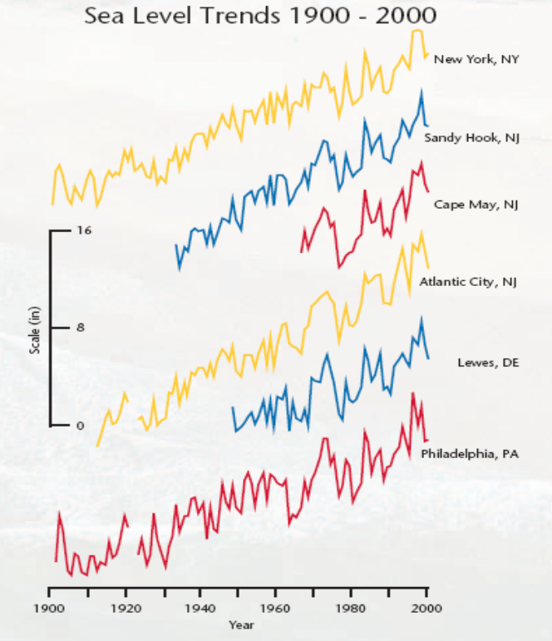
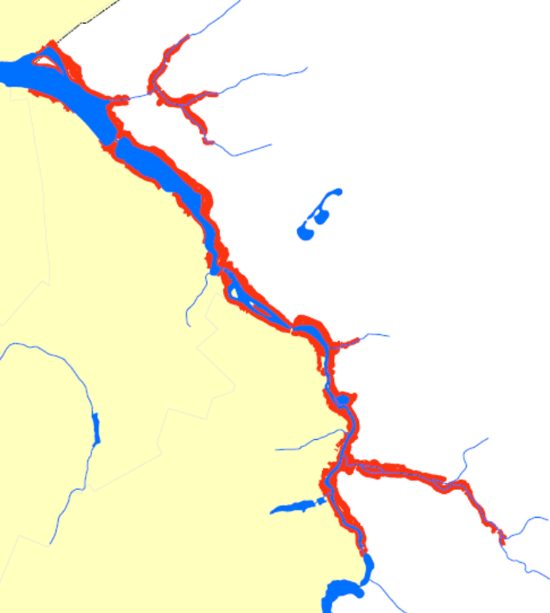
Directly affected by this trend will be the shore communities along the Atlantic Ocean and nearby bays and tributaries, essentially putting the barrier islands below water to current day 100-year flood zones. The 100-year flood level essentially means that the area has a one percent chance of being flooded annually. This is projected to change to flood an average of once a year by 2100, if current conditions continue. These flooding events will be aggravated by storm surge, higher peaks of waves pushed toward shore by the wind force of storms resulting in an increased mean water level increase of 15’ or more. The submersion of Atlantic City casinos and hotels, as well as shore rentals in more residential communities, will have severe affects on the New Jersey shore-based tourism industry. Furthermore, repair and protection techniques against these events will be recurring more often, leading to additional building and insurance costs. This will have secondary affects on Cherry Hill, in the form of direct and indirect employment loss, secondary property damage, and similar disruptions.
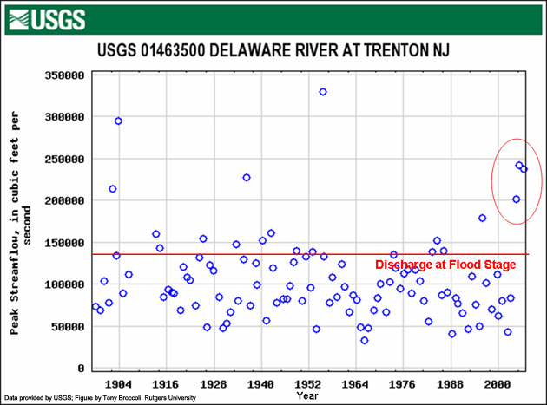

The direct affects in Cherry Hill to rising sea levels would be pronounced by the rise of water in the Cooper River,
The map to the right demonstrates areas in New Jersey that would be flooded during high tide should sea level rise by 2’ and lands that would be prone to flooding are shown in blue.
(http://www.epa.gov/climatechange/effects/coastal/saving_NJ.pdf)
The chart to the left shows flooding events of the Delaware River at Trenton. Three of the seven major flooding events of the last 100 years have occurred since 2000.
(http://climatechange.rutgers.edu/images/delaware_river_floods.jpg)
due to overflow from elevated levels in the Delaware River. Essentially, current areas that flood would flood more often. Areas in red shown here are within the current 2007 flood plain, showing eight (8’) feet or less above sea level. These are the areas that would be most impacted.
The Cooper River would also be affected by the periodic encroachment of salt water from the Delaware River.

Due to rising sea levels, salt water would move farther up rivers from the ocean, thereby increasing the salinity of the Delaware River, consequently increasing the salt content of the Cooper River. In the event of a drought, this highly saline water could recharge water for the Potomac-Raritan-Magothy aquifer, which is a main drinking water source for Cherry Hill Township.

BENEFITS OF A SUSTAINABLE COMMUNITY
In addition to “doing the right thing”, there are tangible benefits to integrating sustainable principles into a community, as outlined in a municipal sustainability plan, including financial savings, improved public health, elevated standard of living, and community-wide economic growth.

The most direct benefit is the monetary savings from energy efficiency improvements, whether done in municipal facilities, in private homes, or businesses. By reducing electricity and fuel costs, there is a direct reduction in operating costs and utility bills. In addition to seeing reduction in daily operations, both homes and commercial businesses may benefit from various tax incentives for “going green.” Deductions are granted for home upgrades to heating, cooling and water heating equipment and systems, energy efficient windows, and assorted similar home improvements.
Most of the strategies that reduce greenhouse gas emissions also have direct benefits to improved public health. While carbon dioxide has no direct impacts to public health, the main causes of greenhouse gas emissions, power plants, buildings and vehicles, also emit sulfur oxides, the leading cause of acid rain and particulate matter in the air, and nitrogen oxides, the leading cause of smog. Air pollution has been shown to cause respiratory disease, trigger asthma attacks, and is increasingly being linked to cardiovascular disease. As we improve energy efficiency, promote production of hybrid vehicles and reduce our dependence on energy overall, there are clear benefits to our public health through improved air quality. In addition to air quality benefits, providing for local policies that promote mixed use residential and commercial development and improved pedestrian and bicycling facilities, can lead to a reduction in vehicle use. This change in behavior not only benefits air quality but may increase daily exercise activity in a country where obesity is a growing epidemic, accounting for 6% of all annual healthcare expenditures.

Communities that are designed to improve the environment often have the positive consequence of creating a stronger sense of community. Getting people out of there cars through improved pedestrian facilities can lead to higher levels of interaction amongst community residents. Access to recreation facilities provide locations for community gatherings and can be focal points of community pride. The process, in itself, of creating a sustainable community can bring together citizens from throughout the community. Businesses, school groups, municipal officials, religious organizations, senior groups and others working towards a common goal can help build a stronger sense of community pride.
Sustainable Community Benefits to Residents
- Establish and maintain a quality of life based on shared values adopted by the community
- Establish links between issues that often are viewed as separate (i.e., economic development, housing, public safety and transportation)
- Equitable distribution of critical resources and opportunities for the current generation as well as for future generations
- Enhanced quality of life/ improved livability
- Economic development that better supports community infrastructure with quality tax bases* and creates potential for increased community prosperity by providing diverse, high-quality local jobs for a greater portion of the population
* That is, reflecting true costs of community resource use and applying “user pays” principle.

SOURCE: How to Become an Environmentally Sustainable Community - A Primer, New Jersey Department of Environmental Protection, Office of Planning and Sustainable Communities, January 2006, Table 1.

From an economic development perspective, promoting sustainability can have numerous benefits to existing and future businesses and residents. Waste reduction, energy efficiency and pollution prevention make economic sense through cost savings, increased efficiency, and better use or possible reduction of tax dollars that go towards municipal waste management services. Sustainable development can form 'niche' enterprises and product lines that provide more jobs and wealth. Sustainable development creates jobs within the community, for example, recycling creates more jobs than conventional waste disposal methods. As recycling rates are exponentially increasing across the country, landfills are being less utilized and green jobs are increasing16.

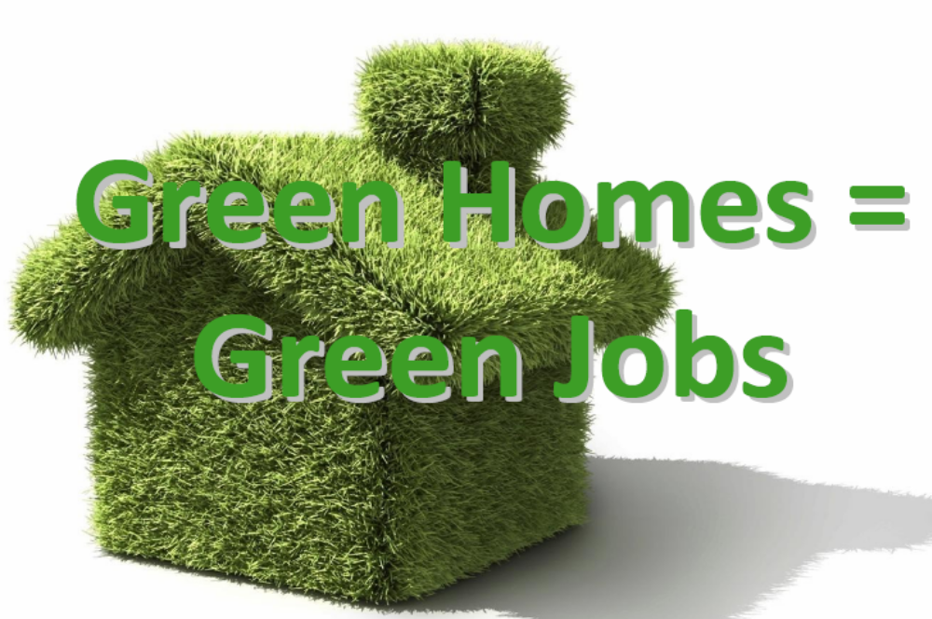

Changes in number of days with heat waves
- Union of Concerned Scientists Northeast Climate Impacts Assessment (October 2006) (http://www.climatechoices.org/assets/documents/climatechoices/NECIA_climate_report_final.pdf)

analysis.
Why analyze? What’s the point? By analyzing our trends and patterns, we will know where to focus our resources to achieve the goals and objectives outlined in this plan. There are several ways to determine where we stand regarding sustainability in our community. One method is conducting a greenhouse gas (GHG) inventory, which is “an accounting of greenhouse gases emitted to or removed from the atmosphere over a period of time.” An inventory of GHG emissions provides insight into the source and amount of emissions. It also provides assistance for a reduction target and prioritizes where to focus emission mitigation policies. An inventory also provides a quantifiable basis for monitoring emission reduction.

BASELINE INVENTORY
Per the Climate Action Handbook, by the Local Governments for Sustainability (ICLEI), “An inventory identifies and quantifies the global warming pollution produced by both government operations and the community at large in a particular year. The inventory and forecast provide a benchmark against which the city can measure the progress in terms of its own operations and that of its citizens. This emissions analysis identifies the activities that contribute to global warming pollution and the quantity of pollution generated by each of these activities. An inventory is established by collecting data about energy management, recycling and waste reduction, transportation, and land use.”
The baseline inventory for Cherry Hill Township relies heavily on the DVRPC Regional Greenhouse Gas Emissions Inventory, which is the initial step in the Delaware Valley Climate Change Initiatives Program Area. In this study, greenhouse gas (GHG) emissions are broken down by region, county, and municipality for the baseline year of 2005. Emissions are generally measured in metric tons of carbon dioxide equivalent (MTCO₂E), which is a standard unit of calculation for emissions. DVRPC reviewed many sources of energy, including those used in the residential, commercial, industrial, transportation, waste, agriculture, and fugitive emissions from fuel systems.
Greenhouse Gas (GHG) Emissions for Cherry Hill (MTCO₂E), 2005
Emissions Source Category | Emissions (MTCO₂E) | % of Total
Stationary Energy Consumption: Residential | 322,176 | 29.6%
Stationary Energy Consumption: Commercial & Industrial | 376,819 | 34.6%
Mobile Energy Consumption | 316,770 | 29.1%
Other | 73,584 | 6.8%
Agriculture | <0.5 | 0.0%
Waste Management: Landfill | 27,206 | 2.5%
Waste Management: Wastewater | 8,979 | 0.8%
Industrial Processes | 25,456 | 2.3%
Fuel Systems Fugitive Emissions | 11,943 | 1.1%
Gross Emissions | 1,089,348 | 100%
Land Use, Land Use Change, and Forestry | -9,373
Net Emissions | 1,079,976

The DVRPC categorizes emissions by the following sources for each municipality, including Cherry Hill:
- Stationary Energy Consumption-Residential: use of energy in homes and related non-mobile uses.
- Stationary Energy Consumption-Commercial & Industrial: use of energy for businesses and related non-mobile uses.
- Mobile Energy Consumption: use of energy in transportation, including on-road transportation, passenger and freight rail, aviation, marine transportation, and off-road vehicles (ORV).
- Agriculture: non-energy emissions from agriculture, including both crops and livestock.
- Waste Management: non-energy emissions related to managing solid waste, including trash and wastewater.
- Industrial Processes: non-energy emissions associated with industrial activity.
- Fuel Systems Fugitive Emissions: leakages in the production, distribution, and transmission of fossil fuels.
- Land Use, Land Use Change, and Forestry (LULUCF): emissions from changes in the amount of carbon stored in soil and plants due to land use and forestry.
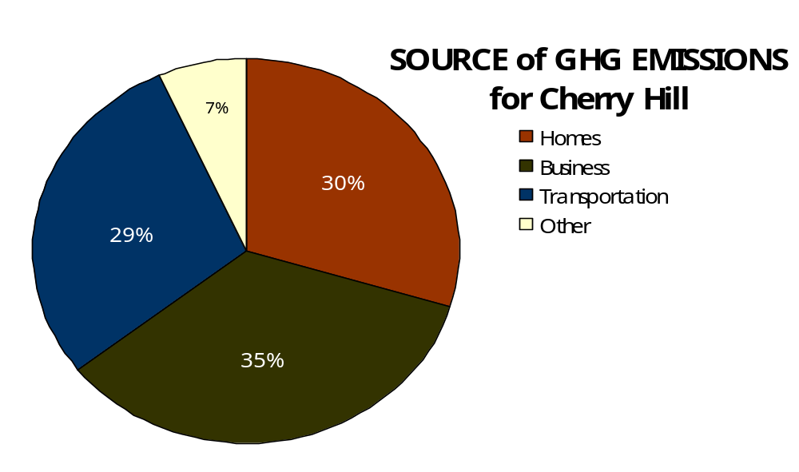
SOURCE: DVRPC, 2005
The data for Cherry Hill Township represented above, shows a majority of the emissions within the Township evenly come from homes (Residential Stationary Energy Consumption), Business (Commercial & Industrial Stationary Energy Consumption), and transportation (Mobile Energy Consumption). The largest emissions generators in the Township are commercial and industrial uses, which produce 35% of the emissions for the Township. Homes and transportation produce roughly the same amount at 30% and 29%, respectively. While other uses, such as agriculture, landfills, wastewater, industrial processing, and fugitive fuel emissions collectively issue 7% of the Township emissions.

Carbon Dioxide (CO₂) emissions come from the use of electricity, heating oils and gas, vehicle use, and waste and consist of several types of emissions including CO₂, methane, nitrous oxide, and fluorinated gases. Methane, nitrous oxide, and fluorinated gases are converted into equivalent CO₂ emissions for ease of determining overall impact. The data reported in Carbon Dioxide emission levels (Metric Tons of CO₂ equivalents – MTCO₂E) are actually emissions of all of the GHG emissions, not just carbon dioxide.
How does Cherry Hill compare nationally?
Total average CO₂ emissions per U.S. household per year (MTCO₂E) = 21.28
Total average CO₂ emissions per Cherry Hill household per year (MTCO₂E) = 20.69
Nationally, Cherry Hill is about average for emissions output with the average household in the U.S. By reviewing recent census data, the Township has an estimated 71,755 residents, that have 48,983 vehicles within 27,833 homes.


48,983 vehicles
27,833 homes
71,755 persons
SOURCE: 2005-2007 American Community Survey 3-Year Estimates; 2000 Census

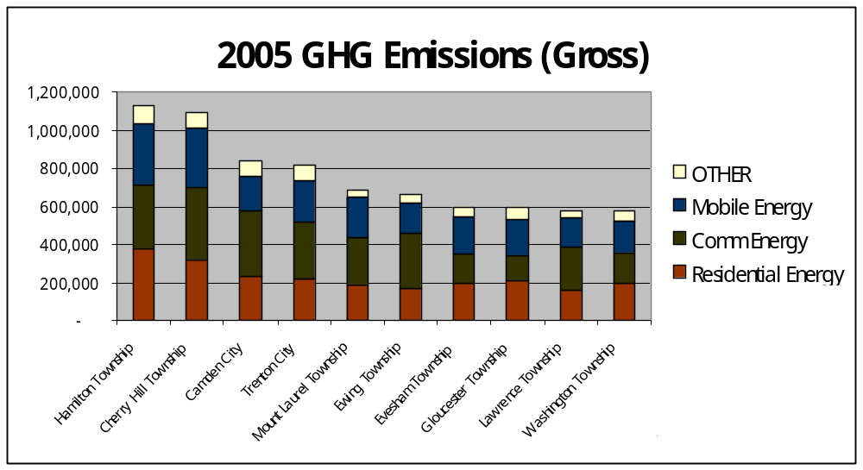
From a regional perspective, Cherry Hill residents have a carbon footprint of an average 14.86 metric tons of greenhouse gas per year. Camden County produces approximately 6.7 million metric tons of greenhouse gas per year. When examining annual GHG emissions from Camden County, Cherry Hill produces 16%23 of the County's emissions, which correlates as Cherry Hill is one of the larger municipalities in the County both in size and population. Furthermore, Cherry Hill is the second highest emission producer (behind Hamilton Township) in the four NJ counties of the DVRPC region (Mercer, Burlington, Gloucester, and Camden).

2005 DVRPC GHG Emissions Inventory; Top Ten New Jersey Municipalities
All emissions in MTCO₂E
Municipality | County | Residential Energy | Comm/Ind Energy | Mobile Energy | Other | Gross Emissions | LULUCF* | Net Emissions
Hamilton Township | Mercer | 378,930 | 331,436 | 325,236 | 91,367 | 1,126,970 | 13,893 | 1,140,863
Cherry Hill Township | Camden | 322,176 | 376,819 | 316,770 | 73,584 | 1,089,348 | (9,373) | 1,079,976
Camden City | Camden | 235,643 | 340,350 | 178,333 | 79,444 | 833,771 | (6,686) | 816,388
Trenton City | Mercer | 220,037 | 299,899 | 214,597 | 81,097 | 815,630 | (2,689) | 812,942
Mt. Laurel Township | Burlington | 189,836 | 242,986 | 211,691 | 40,105 | 684,618 | (1,436) | 683,182
Ewing Township | Mercer | 170,072 | 287,337 | 163,521 | 41,138 | 662,068 | (235) | 661,833
Evesham Township | Burlington | 198,687 | 150,309 | 199,651 | 45,571 | 594,218 | 2,583 | 596,801
Gloucester Township | Camden | 213,994 | 125,930 | 191,443 | 65,133 | 596,499 | 977 | 589,286
Lawrence Township | Mercer | 156,640 | 228,808 | 153,907 | 33,393 | 572,748 | 1,176 | 573,923
Washington Township | Gloucester | 198,095 | 161,360 | 163,991 | 48,800 | 572,245 | (2,877) | 569,368

INDICATORS
What’s an indicator? Why do we need it? Local trends of key items or processes that measure progress and indicate where to direct policy change, determining what is effective and what is not. Indicators also provide evidence and assurance to engage the community and harness support, illustrating the critical role of the local municipality in reducing emissions. Indicators can be generalized into four topics: Land use, transportation, energy, and waste.

LAND USE.
Land use involves the efficient planning and development to shape the appearance of a community. This involves finding the harmonious balance between developed land and open space. The amount of open space is a key indicator of sustainability, as it has a drastic effect on land use patterns and public health. A Recreation and Open Space Inventory (ROSI) database is maintained by New Jersey municipalities that are part of the Green Acres Program administered by the Department of Environmental Protection. This program helps fund the properties for recreational use and keeps track of the both funded and unfunded parklands. The Township has 1,364 acres listed on the 2009 ROSI report. Conversely, approximately 87% of land is developed. Of that, almost 77% of parcels are zoned for single-family residential, which is the lowest density housing zone applied. A key goal pertaining to sustainable land use is to efficiently redevelop land to not increase the amount of developed land, while preserving environmentally significant properties in strategic locations that expand the open space system.
Emerging indicators becoming more common in land use development are the number of green buildings, herein defined as LEED©-certified. Leadership in Energy & Environmental Design (LEED©) Green Building Rating System is a third party certification program by the United States Green Building Council (USGBC). Though various green practices have been integrated into site and building design within the Township in recent years, none have obtained official LEED© certification. Another land use tool to create more sustainable community is the creation of mixed use zones. Mixed use zones create new or enhance (and legalize) existing areas of mixed commercial and residential uses. These zones allow a variety of uses to live and work in the same area, as well as implement physical requirements to construct areas of business and community activity that are walkable. A variety of these zones are available, such as form-based codes, hybrid codes, transit-oriented zones, traditional neighborhood development, and other mixed use zones. The Township currently has one zone that permits a variety of business units and multi-residential dwellings in one area, which is the Regional Business (B4) zone, which is the site of the former Garden State Racetrack.
Why is it important to adopt Green Building strategies?
- Buildings use 70% of the electricity produced in the U.S.
- Every year $150 billion of energy consumed by U.S. buildings is wasted.
- Buildings consume 40% of the World’s resources.24

TRANSPORTATION.
Vehicular transportation dominates the way people get around in the Township and the overall area, but efficient and environmentally-friendly mobility is essential to a sustainable community. Various transportation statistics were found in the American Community Survey (ACS), as part of the Decennial Census Program, for the years 2005-2007. This survey is sent to a small percentage, a sampling, of the population on a rotating basis. Since the ACS is conducted every year, rather than once every ten years, it will provide more current data throughout the decade.
Census data shows that the mean travel time to work for Cherry Hill residents is 26.2 minutes, above the national average of 24.4 minutes. Longer commutes lead to higher congestion in and around the area. Of the approximately 35,000 commuters whose origin is in Cherry Hill, over 80% of them drive alone to work, which is greater than the national average of 76%. Remaining Township residents carpool (7%) or take public transportation (6%). The high availability of cars for each household allows for this, which averages 2 cars per household. Less than one percent of Township households do not have a personal vehicle, while the national average is over eight percent without a vehicle. Emissions reduction would result in the diversification of transportation modes and decline in automobile ownership.
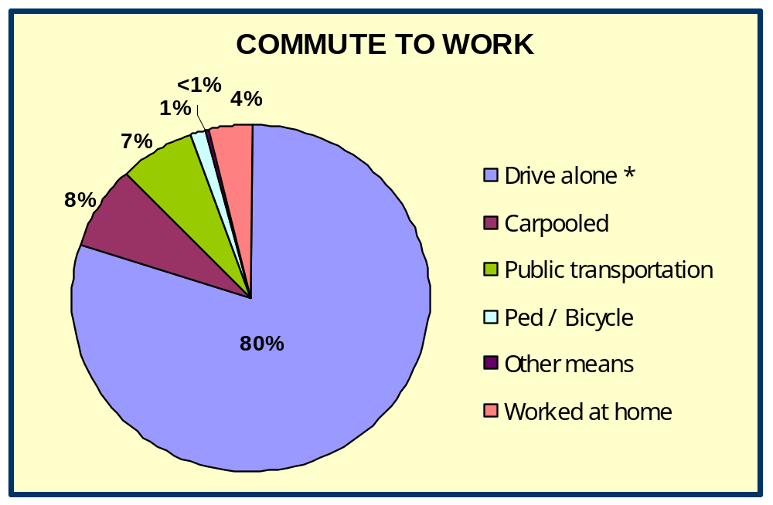

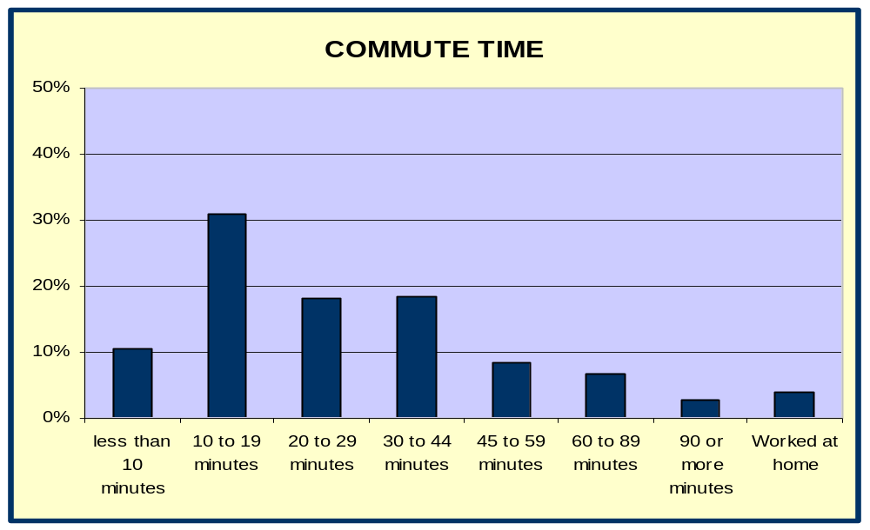

Though changing, the dominance of the automobile is also reflected in the number of trails, bikeways, and bike lanes within the Township, which is approximately five miles in length. Five trails make up the Township trail/bicycle system at this time, which includes the Cooper River Park and adjacent parks of Challenge Grove, Greenwald Memorial Park, and Wallworth Park bike trails. The Colwick Trail, just under a mile in length, is under construction along the South Pennsauken Creek near the northern border of the Township. By increasing the number and length of trails, the Township can provide more opportunities for cycling and walking.
ENERGY.
The Township purchases energy from a number of utilities for the natural gas and electricity provided to Municipal facilities. A full community-wide audit would be needed to determine the usage for the entire Township. To determine annual Municipal use, utility bills for the year 2008 were examined for all providers. PSE&G provides electricity service to municipal facilities, which consist of sixteen buildings (Public Works and Municipal Building complexes, Library, Croft Farm, Barclay Farm, Cherry Hill Police Evidence Buildings, and various smaller sites) and street lights around the Township.
The below chart summarizes municipal energy consumption in structures and infrastructure, which expended 6,368,543 annual kWh for the year 2008. A kilowatt (kWh) or kilowatt-hour expresses a unit of energy equal to 1000 watts for one hour. The largest consumer of energy are the street lights throughout the Township, which accounts for almost 2/3 of the total costs in electricity. Collectively, over $1.2 million dollars are annually spent on energy for Township facilities. Behind street lights, the largest user by a building would be the Cherry Hill Public Library, which spent roughly $215,150 for electricity in 2007.

 | GAS | ELECTRIC | GAS | ELECTRIC
BUILDINGS | Therms | kWh | $ | $
Public Works | 38,317.00 | 318,608.00 | $29,388.07 | $47,895.18
Croft Farm | 21,403.16 | 56,412.00 | 14,995.97 | 11,312.63
Barclay Farm | 2,838.33 | 23,488.00 | 1,192.86 | 4,213.77
CHPD Evidence Building | 3,948.76 | 14,023.80 | 2,958.76 | 2,539.06
Municipal Complex | 41,990.00 | 971,800.00 | 32,092.32 | 160,188.22
Library | 108,497.25 | 1,629,390.00 | 80,627.98 | 215,149.58
Street Lights | 32,287.44 | 3,331,579.80 | 21,308.40 | 795,137.02
various smaller sites | 6,224.83 | 23,241.00 | 5,296.33 | 4,244.73
TOTAL | 255,506.77 | 6,368,542.60 | $187,860.69 | $1,240,680.19
*2007 data used.

Natural gas is supplied to 18 municipal buildings from various suppliers, mainly Woodruff Energy, South Jersey Gas, and PSE&G. During the year 2008, Cherry Hill facilities consumed approximately 255,500 Annual Therms of gas at a cost of approximately $187,861. One Therm is equal to 29.31 kWh or the energy equivalent of burning 100 cubic feet of natural gas. Since gas meters measure volume and not energy content, a therm is used to convert the volume of gas used to its heat equivalent, and thus calculate the actual energy use
Gasoline in the municipal fleet of vehicles was also reviewed, using the 2008 calendar year as a sample. The municipal fleet consists of 266 vehicles for police use, building and zoning inspection, public works infrastructure service, and more. Fuel stations for Township vehicles are located at the Municipal Complex on Mercer Street and the Public Works division on Perina Boulevard. Overall, 211,755.80 gallons of fuel is used annually, equaling to $565,093.50 in costs. This means approximately 796 gallons of fuel is used per year for each municipal vehicle.
Water service providers for the Township are Merchantville-Pennsauken Water Commission on the far west side of the Township and New Jersey American Water Company for a majority of the Township. Most residents are served by New Jersey American Water, which provides 93% of water to the Township. In the year 2008, over 3 billion gallons of water was processed for the overall municipality. The reduction in consumption of electricity, gas, and water by Township facilities, private residences, and businesses will benefit the overall community.

WASTE.
The Township collected almost 35,000 tons of recyclables from the community in 2008, diverting 60% of the total debris from the waste stream, exceeding the standards set by the State of New Jersey Solid Waste Management Plan. These recycled materials include paper, cardboard, glass, metals, appliances, yard waste, oil, tires, e-waste, leaves, and wood chips. In 2008, when the RecycleBank® program started operation in the Township, collection changed separated paper and containers to commingled single stream collection. The seasonal collection of leaves for composting between September and December is the largest item of recycled material, accounting for 53% of all recycled material.

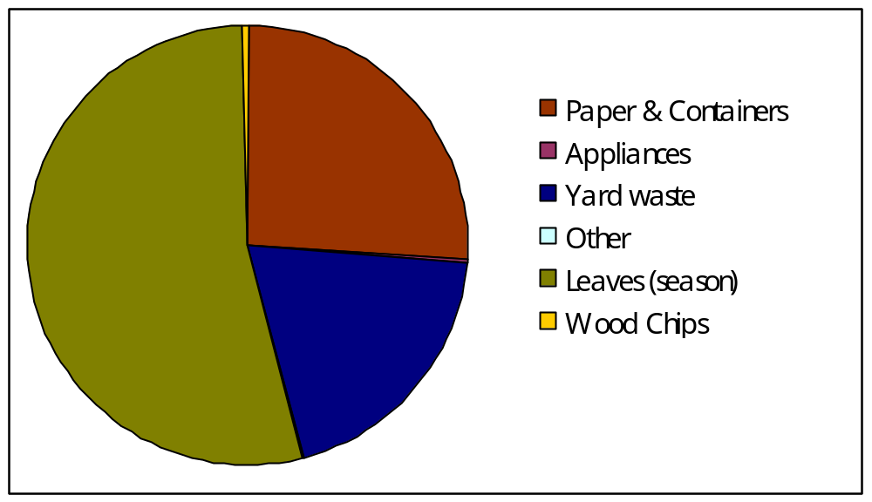
2008 RECYCLING RATES: Cherry Hill

Wastewater is water consumption that is returned to the sewer system, which comprises of sewage, infiltration and inflow water. Infiltration is water other than sewage that enters the system through defective piping or connections. Infiltration levels directly correlates to the increase and decrease in the water table. Inflow is water other than sewage that enters from sources such as roof leaders, cellar drains, yard drains, area drains, and manhole covers and is the direct result of rainfall. Cherry Hill has been averaging roughly 12 million gallons daily in recent years. The amount varies year to year, depending on rainfall.
The major objective of a sustainable sanitary sewer system is to reduce wastewater, which will therefore relieve a sewer system that will reach maximum capacity with the growth of consumption. In addition, a decrease in wastewater will lessen the need for energy to treat the water further down the line. There are several ways to achieve this goal by each segment. Overall, conservation is the best action with the greatest result and minimal cost. Another example is the use of rain barrels to collect rainwater along with native gardening to decrease consumption of water. Also, the reuse of water also known as grey water will contribute to the reductions.

CATEGORY | INDICATOR | CURRENT | SOURCE
LAND USE. | Amount of Open Space (acres) | 1,364 | Recreation and Open Space Inventory (ROSI)
LAND USE. | Amount of Developed Land (percentage) | 87% | Reexamination Report 2007
LAND USE. | Number of Green (LEED©-Certified) Buildings | 0 | Township Records
LAND USE. | Mixed-Use zones | 1 | Reexamination Report 2007
TRANSPOR-TATION | Traffic Congestion: Mean Travel Time to Work (minutes) | 26.2 | US Census, 2005-2007 American Community Survey
TRANSPOR-TATION | Transportation Mode: Percent Driving Alone to Work | 80.2% | US Census, 2005-2007 American Community Survey
TRANSPOR-TATION | Vehicle Ownership: Average Number of Vehicles per Household | 2 | US Census 2000
TRANSPOR-TATION | Miles of bike paths | 5.5 | Camden County Open Space Plan; Rec. Dept.
ENERGY. | Municipal Gas Consumption (Annual Therms) | 223,219.33 | 2008; Woodruff Energy & PSE&G
ENERGY. | Municipal Electricity Consumption (Annual kWh) | 6,368,542.6 | 2008; PSE&G
ENERGY. | Fuel Use for Municipal Vehicles (gallons) | 211,755.80 | Township Records
ENERGY. | Total Municipal Water Consumption (gallons per year) | 2,968,094,000 | NJ American Water & Merchantville-Pennsauken Water Co.
WASTE. | Recycling Rate (Annual Tonnage/% of waste stream) | 34,993 (60%) | 2008; Cherry Hill Public Works Department
WASTE. | Paper & Containers Recycling (Annual Tonnage/% of waste stream) | 9,032 (15%) | 2008; Cherry Hill Public Works Department
WASTE. | Solid Waste Rate (Annual Tonnage/% of waste stream) | 23,365 (40%) | 2008; Cherry Hill Public Works Department
WASTE. | Sanitary Sewer (average gallons per day) | 12,000,000 | Camden County Municipal Utilities Authority (CCMUA)

action plan.
As defined by the U.S. Mayor’s Climate Action Handbook, an action plan is, “a customized roadmap to reduce global warming pollution by the target that your city has identified. The action plan includes an implementation timeline for reduction measures, costs and financing mechanisms, assignments to the various municipal departments, and actions that Cherry Hill should implement to achieve its target. The inventory and quantification of existing climate protection measures helps guide a (municipality) to understand where they can get the largest emissions reductions.”
The Township of Cherry Hill endorses the U.S. Mayors Climate Protection Agreement as written and urges all other government agencies in Cherry Hill, Camden County, and the New Jersey to join this effort. However, additional steps are needed, as outlined in the Sustainability Plan. The following actions can be done internally (within Township government) and externally (for the overall Township). Internal measures refer to the actions a local government can take to reduce the emissions associated with their operations and activities, while external measures target the reductions associated with the operations and activities of Township residents and business owners.

LAND USE. Encourage and facilitate responsible development with efficient land use that reduces sprawl.
1. Implement and standardize efficient land use practices.
a. Promote redevelopment of brownfields and greyfields with existing infrastructure into redevelopment zones.
b. Establish mixed use and historic zones that increase walkability thereby reducing vehicle trips.

c. Research the feasibility of amendments to the Stormwater Management Plan that incorporate new practices and expands upon best management practices (BMP), such as rain gardens, bioswales, and the like, with improved basin design guidelines that utilize native plantings.
d. Encourage co-location of new telecommunications facilities to reduce land consumption and share resources.

2. Establish a municipal Green Building Program.
a. Develop a green building ordinance that follows state or national standards (Green Globe or U.S. Green Building Council LEED®).
b. Educate employees, encourage or sponsor staff to become LEED®-AP Accredited Professionals
c. Provide information about green building to the public through the Township website and community workshops in partnership with community and civic organizations.
d. Create a Green Business Recognition program rewarding companies that utilize green practices.
3. Improve existing and continue to assemble meaningful open space.
a. Explore utilizing conservation easements to obtain sensitive lands not feasible for private development.
b. Hold annual community tree plantings in parks and local government facilities, as well as starting a Township tree sponsorship program.
c. Encourage a program that creates community stewards for neighborhood parks to care for and improve the quality of recreation.
d. Expand of the Meadows Program, which implements “Low-Mow” practices that restrict mowing on parcels to allow naturalized areas to develop where possible.

TRANSPORTATION. Promote transportation and mobility options that reduce pollution emissions.
1. Encourage programs that reduce commuter trips.
a. Promote car-pooling and mass transit use by municipal employees, utilizing programs such as Air Quality Action, TransitChek, Cross County Connection programs, etc.

b. Streamline one-stop permitting and web site functions, such as online payments, to reduce multiple trips by the public
to municipal buildings.
- Incrementally improve municipal fleets for efficiency and less GHG emission.
  - Periodically analyze existing vehicles to see if old and/or under-used vehicles should be retired and maintain a regular maintenance schedule for all vehicles to ensure they are operating at peak performance ability (i.e. proper tire pressure, clean air filters, etc.).
  - Continue to investigate feasibility of alternative fuel vehicles (biodiesel, ethanol, electric, compressed natural gas, etc.) and/or fuel efficient smaller fleet vehicles, as technology and cost efficiency improves.
  - Continue and possibly expand the program of police officers on bicycles and review the use of bicycles for other Departments.
  - Consider providing alternative fuel sources at municipal filling stations.
  - Promote state anti-idling laws of non-emergency municipal vehicles through signage, employee training, and other education methods.

3. Invest in public infrastructure to promote non-vehicular and more efficient transportation systems.
- Improve traffic signal synchronization for optimal efficiency of operating vehicles.
- Standardize pedestrian infrastructure, such as sidewalks, crosswalks, bicycle racks, and walkable design.
- Complete a comprehensive Township Bicycle & Pedestrian Plan to install bike lanes, trails, and similar infrastructure, particularly to complete the River to Bay Greenway.
- Consider coordinating with a car sharing program (Philly Car Share, Zip Car, etc.) to establish services at key locations, such as the Woodcrest PATCO station, NJ Transit Atlantic City Rail Line, Cherry Hill Mall bus hub, and similar locations.

LEED Certification identifies buildings as environmentally sustainable and healthy working environments. (source: www.usgbc.org)

Croft Farm, a part of Cherry Hill’s Green Acres Conservation Program.
(source: www.cherryhill-nj.com)

ENERGY. Utilize cleaner energy sources that minimize negative effects and maximize energy efficiency.
1. Serve as a model of building efficiency, by implementing the recommendation of the municipal energy audit.
a. Install energy-efficient exit sign lighting and any exterior lighting retrofits with energy-efficient fixtures (LED, high pressure sodium)
b. Replace incandescent light bulbs with compact fluorescent light (CFL) and light emanating diode (LED) bulbs in all Township facilities.

c. Consider expanding the number of facilities to install solar panels, green or reflective roofing, on expansive roofs of Township facilities.
2. Establish energy-saving strategies, through government employee policy and training for all community services and facilities.
a. Institute a “lights out when not in use” policy with signage and training.
b. Ensure computers are turned off after work hours by assigning employee to check all stations before closing.
c. Reduce lighting levels where feasible and consider the use of sensory lighting sensors.

3. Encourage energy efficiency of public utilities for emergency services, schools, businesses, and community residents.
- Revisit lighting ordinance to reduce light pollution with upward and/or excessive light levels.

- Promote usage of energy-efficient traffic and street lights (LED, high pressure sodium) in development projects.
- Consider alternative-powered mowers and landscape equipment, over existing gas-consuming machines.

- Examine funding sources to implement a low-income weatherization program into affordable housing programs.
- Support green electricity from solar, geothermal, wind or hydroelectric sources (Clean Power Community Partner).

WASTE. Reduce waste by reducing, reusing, and recycling.
1. Establish internal government paper reduction strategies, through employee policy and training, encouraging Township-wide adoption in public and private sectors.
a. Streamline edocuments processing, educate employees regarding paper waste caused by faxing and printing.
b. Establish Township policy regarding double-side copying of all Township documents.
c. Reuse all paper when possible (i.e. blank back for scrap paper).
d. Strategically remove all Township Departments from junk email, faxes, etc.
e. Restrict black and white printing on all color printers.
f. Pay Township bills on-line.
2. Establish new and improve existing recycling programs.
a. Continue residential recycling program of Recycle Bank.
- Investigate the development of commercial recycling facilities.
- Work with the County to enforce drop off and pick up of yard debris.
- Investigate a municipal program for reuse or recycling of construction and demolition materials.

- Restrict the removal of bulk goods that can be donated for reuse.
3. Increase the use of composting in the Township.
a. Identify funding to distribute compost bins to private residential homes.
- Establish compost bins at municipal facilities for employee use.
- Educate residents of the benefits of composting, utilizing school system and youth programs.

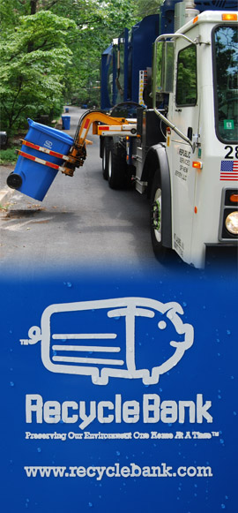

emissions reduction target.

                  








The ultimate goal of this Sustainability Plan is to initiate programs and policies within the Township of Cherry Hill that aim to reduce our carbon footprint and achieve a sustainable balance between the human and natural community. Government, particularly local government, is a central vehicle for coordinating action and achieving sustainability. Leading by example, the programs and policies proposed in this plan intend to stimulate behavioral changes within the community. The following goals address four general areas that are key to reducing the carbon footprint and achieving sustainability, which include land use, transportation, energy, and waste.
Setting a reduction target for global warming pollutants creates a tangible goal and metric to guide the planning and implementation of your community’s action. Many targets have been established on the national, county and local level to meet the collective reduction of greenhouse gas emissions and global warming causing pollutants. The target in the U.S. Mayors’ Climate Protection Agreement is to reduce emissions by a minimum of 7% below 1990 levels by 2012. Local governments supporting the Climate Protection Agreement have generally established GHG reduction targets at 15% or higher to be met within a ten year period. New Jersey’s Global Warming Response Act, the Governor’s Executive Order Number 54, calls for the reduction of greenhouse gas emissions to 1990 levels by 2020, followed by a reduction of emissions to 80% below 2006 levels by 2050.
The Camden County’s 2030 Challenge Resolution sets the following goals and targets:
- All new buildings and developments shall be designed to use half the fossil fuel energy they would typically consume, which is half the U.S. average for that building type.
- At a minimum, an equal amount of existing building area shall be renovated annually to use half the amount of fossil fuel energy they are currently consuming through design, purchase of renewable energy and/or the application of renewable technologies.
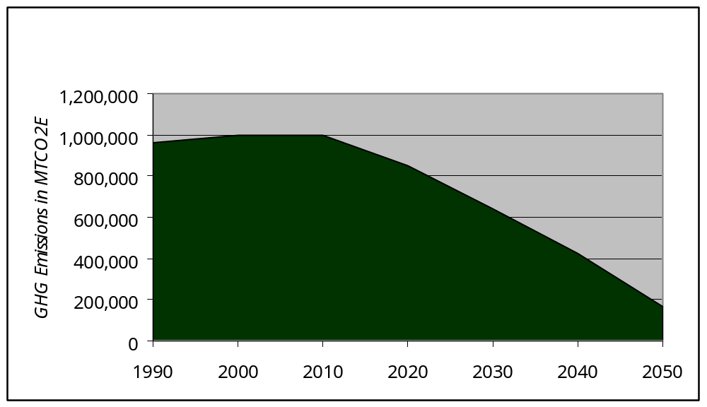
- That the fossil fuel reduction standard for all new buildings be increased to 60% in 2010, 70% in 2015, 80% in 2020, and 90% in 2025.

2005 Emission Level = 1,066,594

The following action plan has identified specific improvements to work toward meeting the statewide emissions target reduction of 20 percent by the year 2020

current initiatives.
The Mayor and Township Council believe specific objectives are needed to combat environmental degradation and remain a leader for other municipalities in the State of New Jersey and throughout the country. As shown in the DVRPC 2005 GHG Emissions Inventory, Cherry Hill is the second largest emitter of GHG’s in the DVRPC Region, behind only Hamilton Township. Through the implementation of the Cherry Hill Green Action Plan, and working in concert with Sustainable Cherry Hill (SCH) and Cherry Hill Environmental Advisory Committee (CHEAC), the Township can become a leader by example for all municipalities in the region.

Cherry Hill Green Action Plan
The Green Action Plan, which served as a precursor to the Township’s Sustainability Plan, was adopted by Township Council on March 10, 2008. This plan endorsed the U.S. Mayors Climate Protection Agreement and laid out a 10-point plan for helping to combat environmental degradation and serve as a leader for other municipalities. The plan put forth the three core initiatives of community partnership, environmental education, and attaining specific environmental objectives to enact the ten action items. The ten action items are:
1. Create benchmarks through an energy audit and carbon footprint calculation. The energy audit has been completed and the recommendations are being implemented.
2. Increase the overall recycling rate in Cherry Hill Township by installing an incentive-based recycling program. RecycleBank® measures the amount of material that each home recycles, then converts it into reward dollars that can be used at any number of local and national rewards partners. Since the program has been implemented, recycling rates have increased from 30% to over 60%.
3. Explore renewable energy resources, including solar energy panels to reduce energy costs in Cherry Hill Township. Funding has been secured from two separate sources to install solar-panels on the Town Hall roof. While reducing the cost of utility bills, these new measures will also create a revenue stream through the selling of energy credits, expected to subsidize up to 20%. of Town Hall’s utility bills (before installation, the energy audit and existing HVAC replacement is required). Improvements are currently underway.
4. Conduct green events and educational forums in Cherry Hill and solicit input from residents and businesses. Over 20 events have already been held in partnership with various organizations, such as the Cherry Hill Environmental Advisory Committee (CHEAC) and Sustainable Cherry Hill.
5. Set an example by becoming a Clean Power Community Partner and encourage residents to do the same, in addition to exploring the opportunity to become a New Jersey Clean Energy Partner. Cherry Hill is now a Clean Community partner with staff attending quarterly conferences.
6. Replace incandescent light bulbs with compact fluorescent light (CFL) and light emanating diode (LED) bulbs and promote usage throughout the Township. The Township has since partnered with Project Porchlight, a green-marketing nonprofit working with the New Jersey Clean Energy Program (NJCEP), to distribute CFL bulbs to residents. To date, several thousand bulbs have been distributed. In addition to this project, light fixtures in Township facilities are being replaced incrementally, with over 60 fixtures replaced.
7. Adopt annual tree-planting program for carbon offsets. An annual tree planting event has been established. To date, over 60 trees have been planted on Township property including Town Hall, Croft Farm, Cooper River Park, with more to be planted.
8. Promote e-Waste recycling and analyze a convenient alternative to properly disposing of E-Waste in Cherry Hill Township. An e-Waste program has since been established at the Cherry Hill Township DPW building. A partnership was formed with Magnum Computer Recycling, and, to date, 41,000 pounds of computers and appliances have been recycled, the largest municipal volume of e-waste in South Jersey.
9. Integrate hybrid and fuel efficient vehicles into the Township fleet. The Township is investigating emerging technology, but has not purchased any additional vehicles at this time.
10. Explore green building incentive plans for future Township construction and development. A draft ordinance is available for public review as an appendices of this plan.
See http://www.cherryhill-nj.com/pdfs/GreenActionResolution.pdf for the complete Green Action Plan.

Sustainable Cherry Hill
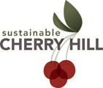
The Township is aided in its pursuit of the three core initiatives by Sustainable Cherry Hill (SCH), a community-based, non-profit organization that furthers a sustainable agenda in the Township.. Through action, positive motivation, education, and partnership, SCH helps members of the community make sustainable-minded decisions without compromising the needs of future generations. SCH consists of two boards—the executive board, made up of seven members who oversee day-to-day operations; and the general board, made up of thirty members, who serve to further the mission and efforts of SCH.
Visit http://www.sustainablecherryhill.org for more information.

Cherry Hill Environmental Advisory Committee (CHEAC)
The Cherry Hill Environmental Advisory Committee (CHEAC) has the mission to protect and improve the natural environment for Township residents. They recently approved an action plan with numerous objectives, such as trail development, natural resource development, and more. CHEAC meets on a monthly basis with Township representatives. More information can be found at www.cherryhill-nj.com.

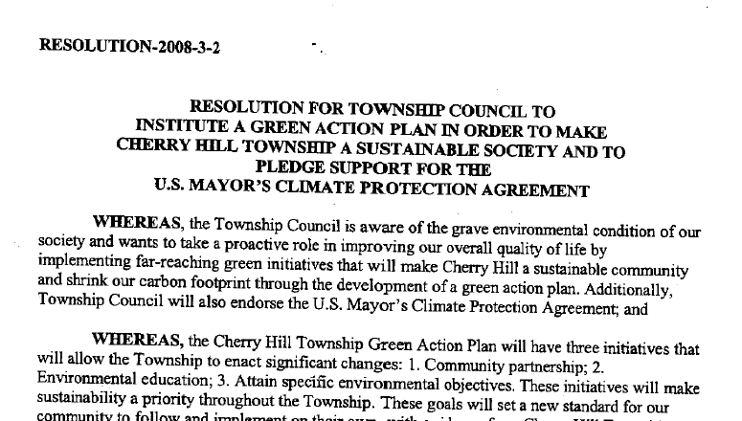

Mayor’s Committee for a Green Future (MCGF)
The Mayor’s Committee for a Green Future (MCGF) is a subcommittee of the New Jersey League of Municipalities (NJLM) with a mission to make New Jersey green, one town at a time. The guiding philosophy is that the local level of government is the one best able to motivate individual citizens to make their lifestyles more sustainable. Mayor Platt currently serves as an Executive Board Member. For more information about the MCGF, visit www.njslom.org.

Camden County Green Initiative

On April 19, 2007, the Camden County Board of Freeholders unanimously passed Resolution #25 entitled, “Resolution Offering County Support for the U.S. Mayor’s Climate Protection Agreement.” With the adoption of this resolution, the County Green Committee began to formulate the County Green Initiative with the full support of the Freeholder Board. During this process, the Green Ribbon Committee was established. The Green Ribbon Committee is composed of Camden County employees that possess expertise in the areas of the environment, sustainability, planning, facility operations, government policy, utilities, and economic development. The Camden County Green Initiative identifies twelve steps adopted by the Freeholder Board, and then recommends action items to be undertaken to achieve them.
1. Inventory global warming emissions in County operations and in the community, set reduction targets and create an action plan.
2. Adopt and enforce land-use policies that reduce sprawl, preserve open space, and create compact, walkable urban communities;
3. Promote transportation options such as bicycle trails, commute trip reduction programs, incentives for car pooling and public transit;
4. Increase the use of clean, alternative energy by, for example, investing in “green tags”, advocating for the development of renewable energy resources, recovering landfill methane for energy production, and supporting the use of waste to energy technology;
5. Make energy efficiency a priority through building code improvements, retrofitting city facilities with energy efficient lighting and urging employees to conserve energy and save money;
6. Purchase only Energy Star equipment and appliances for County use;
7. Practice and promote sustainable building practices using the U.S. Green Building Council's LEED program or a similar system;
8. Increase the average fuel efficiency of municipal fleet vehicles; reduce the number of vehicles; launch an employee education program including anti-idling messages; convert diesel vehicles to bio-diesel;
9. Evaluate opportunities to increase pump efficiency in water and wastewater systems; recover wastewater treatment methane for energy production;
10. Increase recycling rates in County operations and in the community;
11. Maintain healthy urban forests; promote tree planting to increase shading and to absorb CO2; and
12. Help educate the public, schools, other jurisdictions, professional associations, business and industry about reducing global warming pollution.
More information can be found at www.camdencounty.com.

DVRPC Regional Greenhouse Emissions Inventory
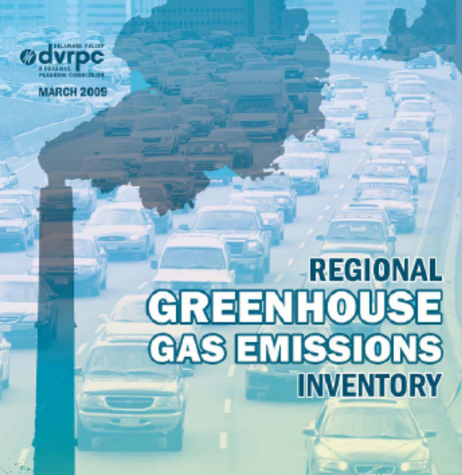
The Delaware Valley Regional Planning Commission (DVRPC), the metropolitan planning organization for the nine county Greater Philadelphia region, established a Climate Change Initiative in 2007. The first task for this Initiative was to inventory greenhouse gas (GHG) emissions in the region, which identified and quantified the emissions sources in the region – Regional Greenhouse Gas Emissions Inventory. Included in this regional analysis is the GHG inventory of the region’s nine counties and 352 municipalities, including Cherry Hill Township.
The Inventory was released in March of 2009 and provides a base line year of analysis of 2005. Greenhouse gas emissions, measured in metric tons of carbon dioxide equivalent (MTCO₂E), are calculated for energy used in the residential uses, commercial uses, industrial sectors, transportation (roadway, rail, aviation, marine, and off-road), waste management (solid waste and wastewater), agriculture processes (both animal and plant related), non energy-related emissions from industrial processes, and fugitive emissions from fuel systems (natural gas systems and petroleum systems).
The Inventory concluded that 1.2% of the nation’s GHG emissions come from the Delaware Valley, while 1.9% of the nation’s population lives in this region. Regional per capita emissions are about one-third lower than the U.S. per capita output. Not surprisingly, the Inventory showed that municipalities with higher density tend to produce lower per capita emissions. The methodology of emissions estimation and allocation are discussed at length in the Inventory.
The next task of the DVRPC Climate Change Initiative is to develop strategies for reducing the region’s GHG emissions. The Regional Greenhouse Gas Emissions Inventory can be found at http://www.dvrpc.org/asp/pubs/reports/09038.pdf .

New Jersey Global Warming Plan
The New Jersey Global Warming Plan provides analysis on how the state can meet and exceed its 2020 statewide limit for emissions, targeting the largest contributors to GHG (Transportation and Energy) by implementing three programs:
New Jersey Energy Master Plan (EMP)
- Reducing peak demand for electricity.
- Improving state building codes.
- Developing renewable energy sources such as wind, biofuels, and solar.
- By investing in clean energy technology.
New Jersey Clean Car Program/Low Emissions Vehicles Program (LEV)
- Setting emissions standards on all cars bought and sold in the state of New Jersey.
- Requiring an average emissions decline each year, until the new minimum is reached in 2010.
- Limiting tailpipe emissions of greenhouse gases.
- Requiring that ten percent of the cars manufactured for sale be either super clean conventional gas-powered vehicles or advanced technology vehicles such as gas-electric hybrids.
Regional Greenhouse Gas Initiative (RGGI). A Regional initiative to limit CO₂ emissions from power plants through a mandatory cap-and-trade program in the Northeast and Mid Atlantic. To limit emissions, the program seeks to:
- Establish a multi-state CO₂ emissions budget (cap) that will decrease gradually until it is 10 percent lower than at the start.
- Require electric power generator to hold allowances covering their emissions of CO_{2.}
- Provide a market-based emissions auction and trading system where electric power generators can buy, sell and trade CO₂ emissions allowances.
- Use the proceeds of allowance auctions to support low-carbon-intensity solutions, including energy efficiency and clean renewable energy, such as solar and wind power.
- Employ offsets (greenhouse gas emissions reduction or sequestration projects at sources beyond the electricity sector) to help companies meet their compliance obligations.
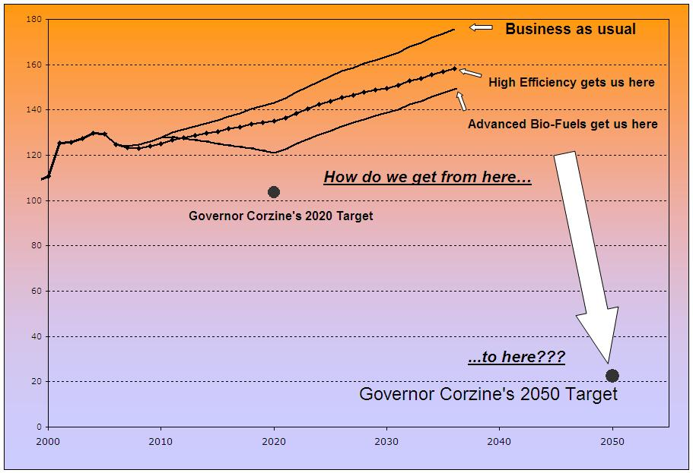
In addition to the three programs listed, the New Jersey Global Warming Plan provides the framework for the development of a new action plan that will give the state a head start in meeting the state’s 2050 limit. This framework goes beyond the initial three, core programs that were previously discussed. An emphasis on land use and transportation, renewable energies and technologies, and energy efficiency will be prevalent. Some of the key parts to this framework include:
- 90 percent of development in New Jersey will occur in areas already served by public infrastructure and 99 percent of that development will be in the form of redevelopment
- Through a combination of energy efficiency requirements and renewable energy sources, all new buildings constructed after 2030 will have a net zero energy consumption
- Promote transit-oriented development
- Ban new coal-fired power plants
- Expansion of mass transit
More information can be found at http://www.nj.gov/globalwarming/
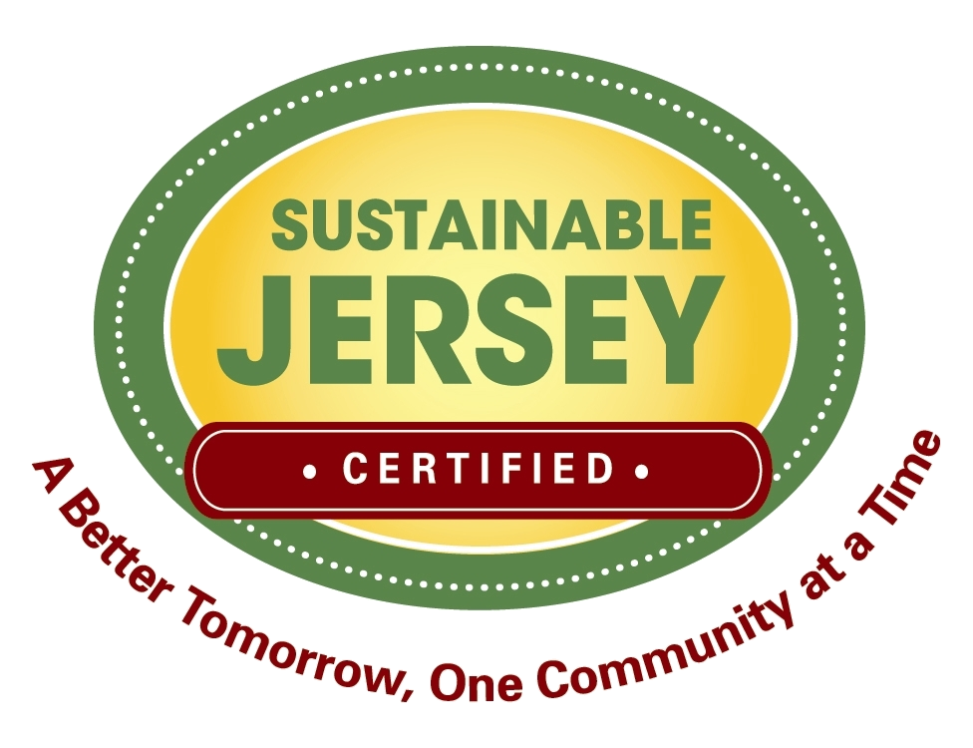
Sustainable Jersey
Sustainable Jersey™ is a certification program for municipalities in New Jersey that want to “go green”. The program provides the following:
- Identifies concrete actions that municipalities can implement to become “certified” and be considered leaders on the path to sustainable community;
- Provides clear guidance and tools to enable communities to make progress on each action; and
- Provides access to grants, and identifies existing and new incentives for municipalities to make progress toward the actions.
“So we will have a choice to make. We can remain one of the world’s leading importers of foreign oil, or we can make the investments that would allow us to become the world’s leading exporter of renewable energy. We can let climate change continue to go unchecked, or we can help stop it. We can let the jobs of tomorrow be created abroad, or we can create those jobs right here in America and lay the foundation for lasting prosperity.”
-President Obama, March 19, 2009
Within two months of inception, over 139 municipalities have registered to become certified, including Cherry Hill. In order to become certified, the municipality must submit an application showing all planned sustainable programs, which gain them points based on the importance given to them by Sustainable Jersey™. More information is available at www.sustainablejersey.com.

implementation.
To implement the necessary actions identified in the Sustainability Plan, with fiscal responsibility, federal, state and county sources of funding will be strategically identified, combined with other forms of revenue. Therefore, this will not impose a negative impact on the taxpayer. All forms of revenue used for these initiatives will be applied in a judicious and austere manner to provide a better quality of life for the Township’s community. The formulation of a Sustainability Plan to improve the environmental quality of life for our community, by acting as progressive leaders to conserve and reduce our overall carbon footprint, is a key priority of the Township.

appendix.
New Jersey Green Municipalities.
Many progressive-thinking New Jersey municipalities have recently adopted sustainability plans or initiatives. In addition, many municipalities are incorporating green building principles and LEED in their redevelopment plans. The Boroughs of Highland Park and Belmar both have launched broad based sustainable building plans for their communities and the Township of Cranford has adopted a green building ordinance. South Orange and Maplewood are exploring energy efficient building design and implementation. The list of municipalities with sustainable initiatives grows by the day.
- Bernards Township Green Team Advisory Committee. By Resolution #070292, this committee was formed in 2007 to advise the township committee on ways to improve municipal operations with “Green” initiatives which are economically and environmentally sound through research and evaluation. http://www.bernards.org/boards_commissions/green_team/default.aspx
- Belmar Borough. In 2006, Belmar produced a sustainability entitled Sustainable Living by the Sea, which consists of eight elements to help create a friendly, walkable, affordable, and sustainable town. In March of 2009, a resolution was adopted to create a Green Team Advisory Committee with representatives of the Belmar Shade Tree Commission (BSTC), Environmental Commission (BEC), Beautification Committee (BBC), Community Garden (BCG), Americans with Disabilities Act Committee (ADA) and Arts Council (BAC). http://belmar.com/green-news/
- My Green Cranford. Cranford Township has an active Conservation & Renewable Resources Committee and Environmental Commission, as well as a progressive Green Building Ordinance that was passed in 2003. http://www.cranford.com/cec/info.asp and www.mygreencranford.org
- Highland Park. Highland Park has many green initiatives in place, guided by the Highland Park 2020 Plan issued in 2002 and the Green Master Plan issued in 2007. The Green Master Plan is a product of Green Highland Park, a partnership between the Borough of Highland Park’s Green Community Working Group and the New Jersey Sustainable State Institute (NJSSI). www.greenhp.org
- Sustainable Hillsborough. Starting in 1999, Hillsborough Township partnered with the New Jersey Sustainable State Institute and the Stony Brook-Millstone Watershed Association to form a community-based project charged to develop an action plan for the future. www.sustainablehillsborough.org
- Sustainable Lawrence. In 2005, a group of residents, businesses, congregations, and other organizations are working towards adopting sustainable policies and practices, using the concept of ‘eco-municipality’ as a model. The program seeks to trace problems to their source and create a ten-year agenda identifying problem areas to improve. www.sustainablelawrence.org
- Maplewood Climate Initiative. A Climate Action Plan was developed by residents and the Environmental Advisory Committee, which was approved in 2007. Maplewood was selected by Clean Air Cool Planet as one of a few municipalities in the country to qualify for a grant to assist in the compiling of the Action Plan. The Plan sets a 20% reduction goal of emissions, which requires a locally addressable CO₂ emissions by 79K tons below current levels by 2015, which is in the implementation phase. www.maplewoodisgreen.org
- Montclair Sustainability. In 2003, a resolution to endorse and adopt a sustainability policy for Township decision making, purchasing and operations. The Montclair Environmental Commission has prepared the Sustainable Montclair Planning Guide to be used as a tool for decision making about the procurement and delivery of public goods and services now and into the future. http://www.mtcenv.org/sustainability
- Newarkcarbon. A project aimed at estimating Newark’s carbon footprint through an accounting of all its sources and take steps toward a more sustainable future. Imagining Newark’s Green Future is the Apollo Alliance’s third major report on new metropolitan development strategies. The Apollo Alliance, a five-year-old national coalition of labor, business, environmental, and social justice leaders, believes that the rapid transition to a clean energy economy is essential to the nation’s safety and prosperity. www.newarkcarbon.org and http://apolloalliance.org/programs/newark/
- Sustainable Princeton. Sustainable Princeton oversees the development of the Sustainable Princeton Project, which includes creating a Sustainable Princeton Community Plan. The group is made up of key officials and local leaders from the business community, civic organizations, congregations, and other stakeholders. http://njssi.org/princeton/
- Summit Green. Mayor’s Sustainable Community Task Force created an Action Plan for a Sustainable Summit in 2008 as a guide to the community for existing and planned initiatives. www.summitgreen.org
- Sustainable West Milford. A community task force that focuses on local farming, gardens, green fest and other community events and programs to raise awareness of sustainability. www.sustainablewestmilford.org
- Sustainable West Windsor. Sustainable West Windsor Plan was a major development project of the Environmental Commission, which produced the Sustainable West Windsor Plan 2007. http://www.westwindsornj.org/EC-sustainability.html
Many more Townships are following suit, and a list of other Townships which have adopted sustainable programs can be found at the NJDEP website: http://www.state.nj.us/dep/opsc/profiles.html. While once a bold step, the creation of sustainable programs and plans is fast becoming the norm. That said, while the quantity of these programs is on the rise, so too is the quality. While earlier versions were broad and had only minimal backing, recently passed plans and boards now have more clearly defined goals, as well as ways to achieve them. This rise in sustainable-minded programs shows a growing awareness in government and the public, and can only lead to heightened efforts with greater effect

More Information
United States Green Building Council (USGBC) www.usgbc.org
Delaware Valley Green Building Council (DVGBC) www.dvgbc.org
Environmental Protection Agency www.epa.gov
Green Globes www.greenglobes.com
Local Governments for Sustainability (ICLEI) www.iclei.org
U.S. Mayor’s Climate Protection Agreement www.usmayors.org/climateprotection
Sustain Lane www.sustainlane.com

? Report of the World Commission on Environment and Development: Our Common Future
Climate Change 2007: Synthesis Report Summary for Policymakers, Intergovernmental Panel on Climate Change (IPCC) 3 Office of the New Jersey State Climatologist, Rutgers University, http://climate.rutgers.edu/stateclim. Values are calculated from an average of monthly temperatures recorded around ten stations throughout southern NJ and are in degrees Fahrenheit. 4 New Jersey: Confronting Climate Change in the U.S. Northeast, Northeast Climate Impacts Assessment (NECIA, 2007). 5 DVRPC, Regional Greenhouse Gas Emissions Inventory, March 2009 6 Climate Change and New Jersey, EPA 230-F-97-008dd, September 1997, Climate and Policy Assessment Division (2174), U.S. EPA, 401 M Street SW, Washington, DC 20460 7 Economic Impacts of Climate Change on New Jersey, July 2008, A Review and Assessment Conducted by the Center for Integrative Environmental Research at University of Maryland 8 Climate Change 2007: Synthesis Report Summary for Policymakers, Intergovernmental Panel on Climate Change (IPCC) 9 Office of the New Jersey State Climatologist, Rutgers University, http://climate.rutgers.edu/stateclim. Values are calculated from an average of monthly temperatures recorded around ten stations throughout southern NJ and are in degrees Fahrenheit. 10 Climate Change in the U.S. Northeast: A report of the Northeast Climate Impacts Assessment, October 2006, Union of Concerned Scientists, www.northeastclimateimpacts.org 11 Cooper River Management Plan, amendment, May 2006 12 Climate Change 2007: Synthesis Report Summary for Policymakers, Intergovernmental Panel on Climate Change (IPCC) 13 New Jersey: Confronting Climate Change in the U.S. Northeast, Northeast Climate Impacts Assessment (NECIA, 2007). 14 http://www.nhc.noaa.gov/HAW2/english/storm_surge.shtml 15 Think Locally, Act Globally: How Curbing Global Warming Emissions Can Improve Local Public Health, Michael R. Bloomberg, Rohit T. Aggarwala, American Journal of Preventive Medicine - November 2008 (Vol. 35, Issue 5, Pages 414-423, DOI: 10.1016(j.amepre. 2008.08.029) 16“As cities and states pass policies to reduce waste going to landfills and incinerators, green collar jobs are increasing exponentially. According to the US Environmental Protection Agency, 50.8 million tons of materials were recycled or composted in 1999, a 50% increase from the previous decade. Throughout the United States over 56,000 recycling facilities, both private and public are creating more than 1.1 million jobs…Recycling creates more jobs than conventional waste disposal methods.” p.11, Green Collar Jobs, by Raquel Pinderhughes, PhD, 2007. 17 ICLEI, Climate Action Handbook, 2007, Page 8 18 ICLEI, Climate Action Handbook, 2007, Page 8 19 Page 4; DVRPC, Regional Greenhouse Gas Emissions Inventory, March 2009 20 558,110.56/26,973; 2005-2007 American Community Survey 3-Year Estimates, S1101. Households and Families 21 1,066,594/71,755 (Cherry Hill Net Emissions/Cherry Hill Residents) 22 DVRPC, Regional Greenhouse Gas Emissions Inventory, March 2009 23 Camden County MTCO₂E = 6,669,000; (Cherry Hill Net Emissions/Camden County Net Emissions) 24 DVRPC Planning for Sustainability: Green Codes & Planning; October 6, 2008, Sandy Wiggins

